Marketing strategy of Apple

Apple’s Vision Statement

“We believe that we are on the face of the earth to make great products and that’s not changing. We are constantly focusing on innovating. We believe in the simple not the complex. We believe that we need to own and control the primary technologies behind the products that we make, and participate only in markets where we can make a significant contribution. We believe in saying no to thousands of projects, so that we can really focus on the few that are truly important and meaningful to us. We believe in deep collaboration and cross-pollination of our groups, which allow us to innovate in a way that others cannot. And frankly, we don’t settle for anything less than excellence in every group in the company, and we have the self- honesty to admit when we’re wrong and the courage to change. And I think regardless of who is in what job those values are so embedded in this company that Apple will do extremely well.”

Apple’s Mission Statement

“Apple designs Macs, the best personal computers in the world, along with OS X, iLife, iWork and professional software. Apple leads the digital music revolution with its iPods and iTunes online store. Apple has reinvented the mobile phone with its revolutionary iPhone and App store, and is defining the future of mobile media and computing devices with iPad.”

SWOT analysis of Apple

1-Strengths:
- Innovative
- Easy to use
- Brand
- Quality

2-Weakness:
- Price
- Pictures
- User interface (touch screen)

3-Opportunities:
- Increasing demand & expansion to new target segmant
- Upgradeable
- Partnerships

4-Threads:
- Increase competition
- Downward pricing pressure

BCG Matrix of Apple:

1-Question Mark- Apple TV makes a bit of money, but it’s not reaching it’s potential. If Apple can solve a few ecosystem problems, they could really own the TV space. There are tons of rumors of an Apple TV product that might just maybe dominate like the iPod/iPhone/i Pad
2-Rising Star -The iPhone and i Pad are rising stars.
3-Cash Cows-The Mac Books are the portables of choice right now. The all-in-one i Mac is in that cash cow place.

4-Dogs- iPods
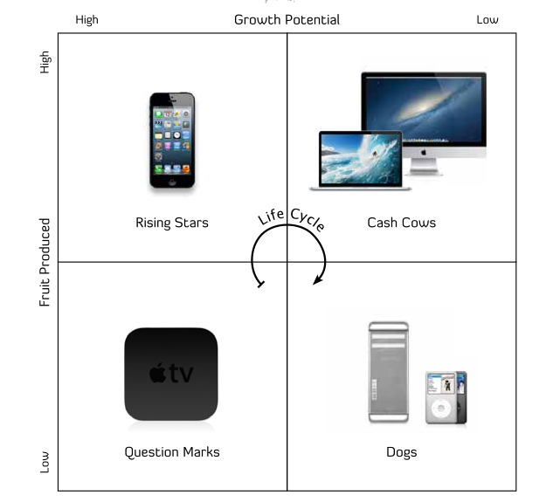

Marketing Mix of Apple:

1-Product:

- Adding the Following Features to the iphone (large disk storage capacity , Lower weight , Thinner device , Long battery Life , 4G wireless , GPS and improved camera )

- Full year warranty along with an optional three-year Apple Care warranty

2-Price:

- set the base model at a cheap price of $349

- A more advanced model for $399

- Generally lower our prices to ensure we establish market dominancein as short of time as possible

3-Place:

- All Apple Stores and Apple website will dedicate themselves to the iphone

- apple stores will have the iphone on display a full month before its worldwide releas

- eye catching display will be found at all physical stores featuring the. iphone to make the product stand out from the pack

4-Promotion:

- a massive tv campaign is planned before launching time iphone featuring soon to be legendary ad to be the talk of the country

-advertising will be appearing on a regular basis tomaintain general public awereness

- Differentiate the iphone against other is the touch screen functionality

Competitive advantage of Apple:

-Brand: According to Forbes, Apple is the World’s most valuable brand . It grew 6% last year.

-Apple Fans: Millions of people will buy whatever Apple sells. A bigger phone? that’s great innovation, they’ll buy it. A smaller phone? genius. Sold.

- A good design heritage: I use the word heritage because it seems Apple still has design talent

-Lock-In: Apple virtually forces uses to use the AppStore.

